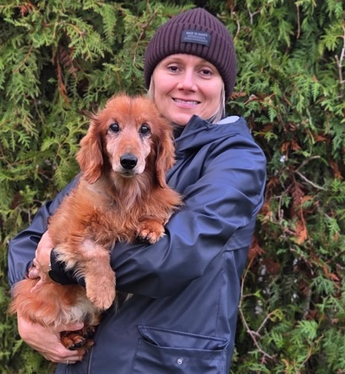
Hello my dear friend Tenzin Rigzin,
I am writing you with my mom. We both have name Štěpánka. We are teachers.
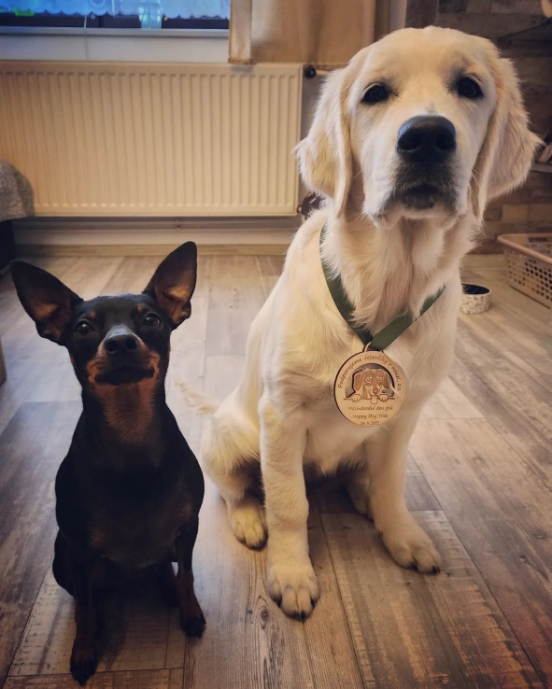
I read that you like horses. We also have horses at home and we have dogs too. I am sending you their pictures.
We hope you like school. We are sending you some things. We hope they make you happy.
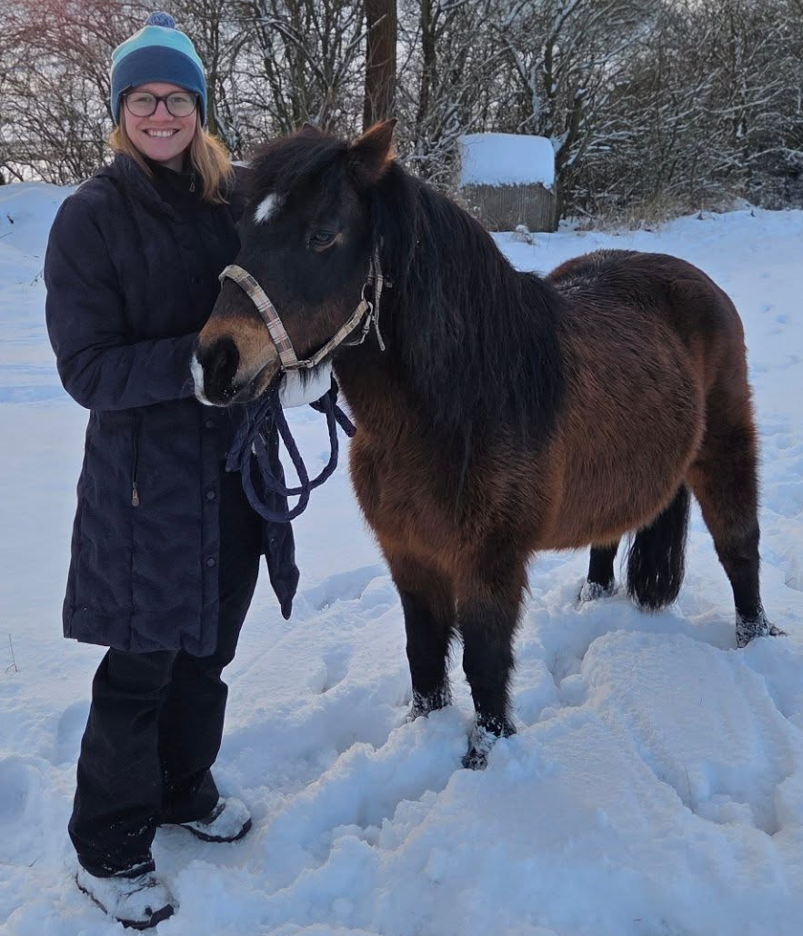
We are looking forwars to your letter.
Take care.
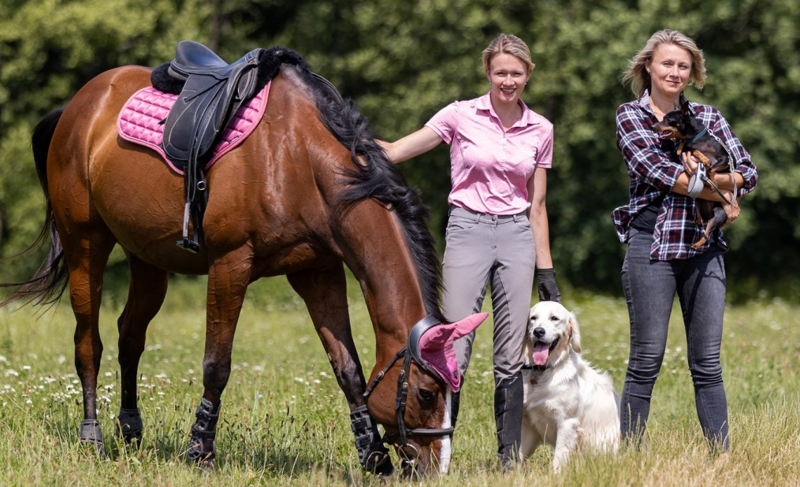
With love, Štěpánka and Štěpánka

